Cartney Thompson

9/19/18

IST 652

**Noise Complaints in New York City**

Final individual project report

***Introduction***

Parties happen in New York City. This is not a surprise. However, often noise complaints are filed when parties occur. The questions this reports answers are the following:

Are noise complaints likely to occur at times throughout the day/month/year? This question will be answered by the percentage of noise complaints by month, day, and hour of the day.

Are noise complaints more likely to come from specific areas of the city? We will answer this question based upon the percentage of noise complaints by borough.

What are the characteristics of where the most (top 10) noise complaints occur? For this question, we will address by counting the number of noise complaints per capita by census tract and pull census characteristics (income, ethnicity, and population).

The NYC noise complaint data was obtained from the New York City Hotline for Noise Complaints via Kaggle **(**[**https://www.kaggle.com/somesnm/partynyc#party_in_nyc.csv**](https://www.kaggle.com/somesnm/partynyc#party_in_nyc.csv)**).** The New York city hotline receives non-urgent community concerns, which are made public by the city via the New York City Open Data portal. The full dataset contains a variety of complaints ranging from illegal parking to customer complaints. This dataset however, focuses on noise complaints that were collected in 2016. Within the file, there are eight data columns:

* Created Date – The date the noise complaint was filed
* Closed Date – The date the New York City Police Department resolved the complaint
* Location Type – The location the noise complaint took place. The location types are:
* Club/Bar/Restaurant
* House of Worship
* Park/Playground
* Residential Building/House
* Store/Commercial
* Street/Sidewalk
* Incident Zip code – The zip code of where the noise complaint took place
* City – The city of the noise complaint
* Borough – The borough of the noise complaint. In New York City, there are five boroughs:
* Manhattan
* Brooklyn
* Queens
* Bronx
* Staten Island
* Latitude
* Longitude

Utilizing this dataset of noise complaints and New York City Census data **(**[**https://www.kaggle.com/muonneutrino/new-york-city-census-data#nyc_census_tracts.csv**](https://www.kaggle.com/muonneutrino/new-york-city-census-data#nyc_census_tracts.csv)**)** to learn more about locations where noise complaints are filed, we are going to perform an analysis to answer the questions listed above. The python program outputs data to help answer the questions posed at the beginning of this report. This data in the program includes:

* The total number of complaints
* Percentage of complaints by month, day, and hour of day
* Percentage of complaints by location type and borough
* Census characteristics of top 10 noise complaints by zipcode

***Data Preprocessing***

To perform analysis on the noise complete dataset, there are some preprocessing steps that need to occur beforehand. These preprocessing steps include:

1. **Incorporating three different files**

The files used as part of the analysis include the noise complaint file. This file contains more than 225K noise complaints from 2016.

In addition to the noise complaint file, two additional census files are included. One file that contains census information for New York City by census tract, and another file that contains census block latitude/longitude locations. We use the census block file to obtain all census blocks that make up a census tract. Census block latitude and longitude coordinates are then used to obtain the nearest census tract a complaint originates

1. **Removing complaints where the location was not recorded**

For any complaints where no geographic information exists, we will remove from the dataset. Of the roughly 225k rows in the noise complaint dataset, 1.4K did not have latitude/longitude values (roughly 0.06% of the dataset). These records were removed from the dataset.

1. **Only including census data from New York City and the five boroughs**

Since this is an analysis of noise complaints in New York City, we will remove census data from elsewhere. This will allow our program to run faster.

1. **Combining the complaint data and census data based upon location. For this analysis, this involved converting latitude/longitude of complaints to the nearest census tracts to understand more about the geographic area the noise complaint comes from.**

We will create a single data frame consisting of the noise complaint data, the nearest census block to where the noise complaint occurred, and the census information (based upon census tract) of where the noise complaint occurred.

***Data Exploration***

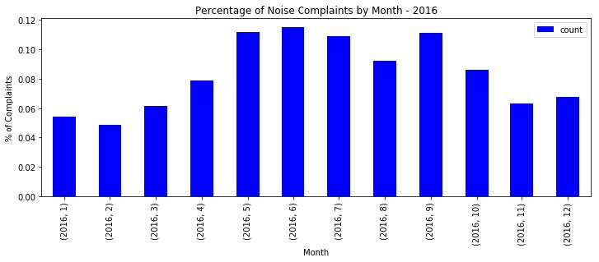Exploring our data, we find of the roughly 223,391 noise complaints in 2016, more than a third of all noise complaints throughout the year occurred during the months of May – July **(Figure 1).**

Examining further, we can see that noise complaints do spike at certain days throughout the year. Nine of the top 10 days in terms of noise complaints all center around holiday or special event weekends in New York City **(Table 1)**.

Figure 1: Percentage of Noise Complaints by Month for the year 2016

|  |  |  |
| --- | --- | --- |
| Date | Description | Number of Noise Complaints |
| 6/19/2016 | Weekend before official start of summer (Event) | 2,528 |
| 7/3/2016 | The Sunday before Independence Day (Holiday Weekend) | 2,323 |
| 9/4/2016 | The Sunday before Labor Day (Holiday Weekend) | 2,311 |
| 5/29/2016 | The Sunday before Memorial Day (Holiday Weekend) | 2,160 |
| 6/18/2016 | Weekend before official start of summer (Event) | 2,106 |
| 9/3/2016 | The Saturday before Labor Day (Holiday Weekend) | 1,994 |
| 6/25/2016 | The Saturday of Pride Weekend (Event) | 1,982 |

Table : Nine of ten days with most noise complaints in NYC for the year 2016

In general, noise complaints occur mostly late night and early hours. More than 70% of noise complaints occur between 9pm and 3a. Given this fact, more than 67% of noise complaints occur Thursday late night into the early hours of Sunday mornings **(Figure 2).**

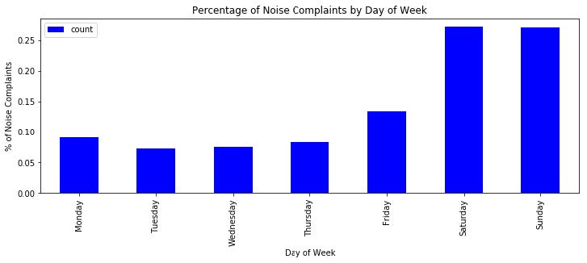Now that we know most noise complaints occur during holiday/special event weekends and during the early hours of the morning, another question we want to answer is do these noise complaints come from specific locations and areas of New York City? One way we can answer this question is by exploring noise complaints by location type and borough. Most specifically, do most noise complaints complain about residential units vs. commercial buildings being loud? Are specific boroughs of New York City more likely to file noise complaints vs. another?

Let’s explore noise complaints by location types first. In NYC during 2016, more than 65% of noise complaints were about residential buildings and homes **(Table 2)**. Only 7% of total noise complaints were about Club/Bars/Restaurants. This probably has more to with good sound insulation at clubs/bars/restaurants or their tendency to be away from residential units. Not surprisingly, houses of worship registered less than 1% of noise complaints. However, of the 598 noise complaints from houses of worship, 86% of complaints occurred on Sundays during the day, a much different trend from what we see for noise complaints overall.

Figure 2: Percentage of noise complaints by day of week in NYC for the year 2016

|  |  |
| --- | --- |
| Location Type | % of Noise Complaints |
| Residential Building/House | 65% |
| Street/Sidewalk | 19% |
| Store/Commercial | 8% |
| Club/Bar/Restaurant | 7% |
| Park/Playground | 1% |
| House of Worship | 0% |

Table : Percentage of noise complaints by location type in NYC for the year 2016

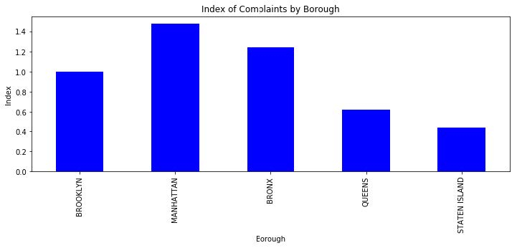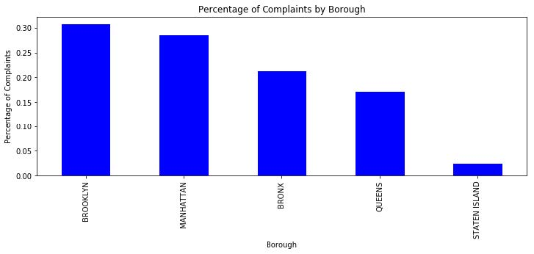 Next, we will answer our question about noise complaints and geo location. As shown in **Figure 3**, by borough, highest percentage of noise complaints come from Brooklyn, Manhattan, Bronx, Queens, and Staten Island respectively. However, this could be a function of the population of each borough. Adjusting for the borough’s population, we use index to measure likelihood of calling in a noise complaint **(Figure 4)**. Using 1.0 as a baseline, residents in Manhattan are 47% more likely than the typical New Yorker to file noise complaints. Bronx residents are 24% more likely, and Brooklyn residents are as likely as any New Yorker to submit noise complaints. Queens and Staten Island residents are less likely to submit noise complaints.

Figure 4: Index of noise complaints by Borough

Finally, we want to know the characteristics of the top census tracts based upon noise complaints per capita. As mentioned above, we chose noise complaints per capita to adjust for most noise complaints coming from the census tracts with highest populations. To calculate noise complaints per capita, we take the number of noise complaints and divide it by the population of that census tract. Below in Table 3, we see the demographics of the top 10 census tracts based upon complaints per capita.

Figure 3: Noise complaints by Borough

|  |  |  |  |  |  |  |  |  |  |  |
| --- | --- | --- | --- | --- | --- | --- | --- | --- | --- | --- |
| CensusTract | County | Borough | Complaints | ComplaintsPerCapita | TotalPop | Hispanic | Black | Asian | White | Income |
| 36061010900 | New York | Manhattan | 564 | 3.032258 | 186 | 1.1 | 10.2 | 27.4 | 58.1 | 135750 |
| 36061009600 | New York | Manhattan | 232 | 1.557047 | 149 | 4.7 | 0 | 32.2 | 55 | 135313 |
| 36081056100 | Queens | Queens | 87 | 0.725 | 120 | 12.5 | 37.5 | 17.5 | 23.3 | 112188 |
| 36047002901 | Kings | Brooklyn | 1998 | 0.565685 | 3532 | 29 | 45.4 | 22.5 | 1.9 | 17544 |
| 36047024500 | Kings | Brooklyn | 1125 | 0.291829 | 3855 | 3.9 | 74.9 | 4.7 | 13.6 | 51605 |
| 36005033400 | Bronx | Bronx | 331 | 0.229702 | 1441 | 60.7 | 26.2 | 3.2 | 10 | 45739 |
| 36061010100 | New York | Manhattan | 285 | 0.22637 | 1259 | 5.8 | 4.7 | 34.6 | 52.3 | 159821 |
| 36081008500 | Queens | Queens | 256 | 0.224956 | 1138 | 43.6 | 2.3 | 17.6 | 28.5 | 34904 |
| 36005040701 | Bronx | Bronx | 695 | 0.217664 | 3193 | 72.1 | 19.2 | 1.2 | 4.2 | 30354 |
| 36005017701 | Bronx | Bronx | 1074 | 0.217145 | 4946 | 62.6 | 35.7 | 0.2 | 1.2 | 25022 |

Table : Demographics of top census tracts by noise complaints per capita

Census tracts that have extremely high incomes, have the highest noise complaints per capita. This makes given that expensive neighborhoods are quieter than busy neighborhoods with a lot of foot traffic.

***Conclusion***

After analysis, we can make the following conclusions about noise complaints in New York City during 2016:

1. Noise complaints occur most from May – Early September. This is due to the many holidays and events (Memorial Day, 4th of July, Labor Day, Pride Festival) that take place during the summer months in New York City
2. Not surprisingly, noise complaints occur most in the late night/early hours on the weekend. This is a time when most people are either socializing or sleeping. Any disturbances to the latter lead to complaints.
3. Nearly two-thirds of noise complaints called in complain about noise coming from Residential Buildings/Houses. Add in the 19% of noise complaints from streets/sidewalks and more than 85% of noise complaints come a home or potentially outside of a place of residence.
4. Manhattan residents are most likely of any Borough to call in a noise complaint. Staten Island is least likely. This tells us that either Staten Islanders are passive and do not call in noise or maybe loud social gatherings do not happen as often as they do in other boroughs such as Manhattan. Therefore, fewer opportunities to phone in noise complaints. My money is on the latter.
5. The top census tracts in terms of noise complaints per capita are from areas with high household incomes. This could be because affluent neighborhoods have less people out in the early hours.